

**Compte rendu TP 3 :**

Atelier Java

**Travail réalisé par :**

Mohamed Aziz Bellaaj

**Groupe :** GL 2/2

1. ArrayTest

|  |
| --- |
| public class ArrayTest{  public static void main(String [] args){  int[] tab1 = new int[10];  int s=0;  for(int i=0;i<10;i++){  s+=i;  tab1[i]=s;    }  System.out.println("tab1 contient");  for(int i=0;i<10;i++){  System.out.print(tab1[i] + " ");  }  int tab2 [] = new int[10];  for(int i=0;i<10;i++){  tab2[i]=i;  }  System.out.println();  System.out.println("tab2 contient les entier de 0 à 9");  for(int i=0;i<10;i++){  System.out.print(tab2[i] + " ");  }  int tab3 [] = new int[10];  for(int i =0; i<10;i++){  tab3[i]=tab1[i]-tab2[i];  }  System.out.println();  System.out.println("tab3 contient la différence entre tab1 et tab12");  for(int i=0;i<10;i++){  System.out.print(tab3[i] + " ");  }  //compte rendu 1  }  } |

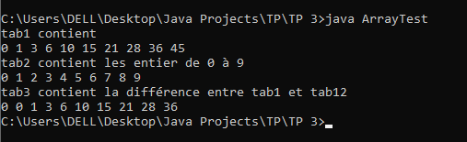

1. Init/AnotherInit

|  |
| --- |
| public class AnotherInit{  AnotherInit(){System.out.println("AnotherInit no-arg const"); }  static { System.out.println("AnotherInit 1st static init"); }  { System.out.println("AnotherInit 1st instance init"); }  { System.out.println("AnotherInit 2nd instance init"); }  static { System.out.println("AnotherInit 2nd static init"); }  } |

|  |
| --- |
| class Init extends AnotherInit{  Init(int x) {  System.out.println("1-arg const");}  Init() {  System.out.println("no-arg const"); }  static { System.out.println("1st static init"); }  { System.out.println("1st instance init"); }  { System.out.println("2nd instance init"); }  static { System.out.println("2nd static init"); }  public static void main(String [] args) {  new Init();  new Init(7);  }  } |

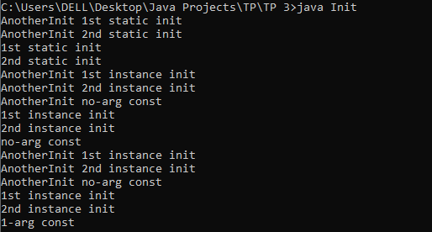

1. AnotherAutoboxing

|  |
| --- |
| class AnotherAutoboxing{  public static void main(String [] args){  Double i1 = 126.0;  Double i2 = 126.0;  if(i1 != i2)  System.out.println("different objects");  if(i1.equals(i2))  System.out.println("meaningfully equal");  Double i3 = 0.0;  Double i4 = 0.0;  if(i3 == i4) System.out.println("same object");  if(i3.equals(i4)) System.out.println("meaningfully equal");  }}  //always different |

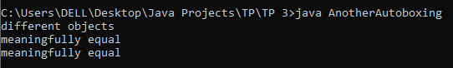

4)AddBoxing

|  |
| --- |
| class AddBoxing {  void doX(Float x, Float y) { System.out.println("Float, Float"); }  void doX(long... x) { System.out.println("long... "); }  void doX(Integer x, Integer y) { System.out.println("Integer, Integer"); }  void doX(Byte n, Byte m) { System.out.println("Byte, Byte"); }  void doX(Double x, Double y){System.out.println("Double, Double");}  public static void main(String[] args) {  new AddBoxing().go();  }  void go() {  short s = 7;  doX(s,s);  } } |

